Multimodal Fake News Detection

Minor Project Report
Submitted in partial fulfilment of the requirements
for the award of the degree of
MASTER OF TECHNOLOGY
In
Computer Engineering (AI & ML)

Submitted by:
Mohd. Suhail
Roll No.-24MAL014

Under the supervision of
Dr. Mohammad Zeeshan Ansari
Associate Professor

Department of Computer Engineering
Faculty of Engineering and Technology
Jamia Millia Islamia
New Delhi
December 2025

CERTIFICATE
This is to certify that the project entitled “Human Centric Multi-Modal Fake News Detection” has been carried out by Mohd Suhail, Roll No. 24MAL014, a student of Master of Technology in Computer Engineering (Artificial Intelligence & Machine Learning) at Jamia Millia Islamia, New Delhi, in partial fulfilment of the requirements for the award of the said degree.
The work presented in this report is original and has been carried out under my guidance and supervision during the academic year 2025–2026. To the best of my knowledge, this project has not been submitted earlier, either in full or in part, to any university or institute for the award of any degree, diploma, or fellowship.
The project work reflects the student’s sincere efforts, technical understanding, and analytical abilities.

Dr. Mohammad Zeeshan Ansari, Prof. Mohammad Amjad,
Associate Professor, Head of Department
Dept. of Computer Engineering,
Jamia Millia Islamia
Date: ________
Place: New Delhi

DECLARATION

I hereby declare that the project work titled “Human Centric Multi-Modal Fake News Detection” submitted to Jamia Millia Islamia in partial fulfilment of the requirements for the award of the degree of Master of Technology in Computer Engineering (AI & ML) is an original work carried out by me under the guidance of Dr. Mohammad Zeeshan Ansari.
I further declare that this project work has not been submitted earlier, either wholly or partially, to any other university or institution for the award of any degree or diploma. All sources of information used in this report have been duly acknowledged. The results presented in this report are based on the experimental work carried out by me during the project period.

Name: Mohd Suhail
Roll No.: 24MAL014
Date:_________
Place: New Delhi

ACKNOWLEDGEMENT

I would like to express my sincere gratitude to Dr. Mohammad Zeeshan Ansari for his invaluable guidance, continuous encouragement, and constructive suggestions throughout the course of this project. His constant support and technical insights played a crucial role in the successful completion of this work.
I am also thankful to all the faculty members of the Department of Computer Engineering, Jamia Millia Islamia, for providing the necessary academic support and for sharing their knowledge during my postgraduate studies. I would like to acknowledge the university for providing the required infrastructure, laboratory facilities, and learning environment that enabled me to carry out this project effectively.
I extend my heartfelt thanks to my classmates and friends for their cooperation, discussions, and moral support during the course of this work. Finally, I am deeply grateful to my family for their constant encouragement, patience, and support, which motivated me throughout this academic endeavour.

ABSTRACT

Fake news refers to intentionally fabricated or misleading information presented as factual content, often designed to influence public opinion or generate online engagement. With the rapid expansion of social media, such misinformation spreads faster and reaches wider audiences than ever before, posing significant societal risks.
This project investigates a multimodal fake news detection system that evaluates both textual content and accompanying images rather than relying solely on headlines, URLs, or isolated text. Multiple benchmark datasets—including GossipCop and Politifact—were collected, cleaned, merged, and pre-processed to build a unified dataset suitable for multimodal analysis.
For feature extraction, Sentence Transformers were used to generate dense text embeddings, while Convolutional Neural Networks (CNNs) such as ResNet50 were employed to extract image features. These representations were subsequently fused and passed through fully connected and activation layers, with a final sigmoid-based classifier predicting whether a news item is real or fake.
Experimental findings indicate that integrating both text and image modalities significantly enhances detection accuracy. The model performs better at identifying manipulated visuals, mismatched media–text pairs, and clickbait-driven deception compared to traditional text-only methods. Although challenges such as dataset imbalance, noisy media content, and high computational cost persist, the system demonstrates strong potential to support social media platforms and fact-checking organizations in mitigating misinformation at scale.

TABLE OF CONTENTS
Serial No. | Title | Page No.
1 | Certificate | 2
2 | Declaration | 3
3 | Acknowledgement | 4
4 | Abstract | 5
5 | Table of Contents | 6
6 | List of Figures/Tables | 7
7 | Chapter 1:Introduction | 8
8 | Chapter 2:Literature Review | 10
9 | Chapter 3:Dataset | 12
10 | Chapter 4:Proposed Methodology | 15
11 | Chapter 5:Experimental Results | 17
12 | Chapter 6:Conclusion and Future Work | 21
13 | References | 23
LIST OF FIGURES
Figure No. | Figure Title | Page No.
Figure 4.1 | Proposed Methodology | 16
Figure 5.1 | Confusion Matrix(a) and Classification Report(GossipCop) | 18
Figure 5.2 | Precision Recall Curve(a) and ROC Curve(b) (GossipCop) | 19
Figure 5.3 | Confusion Matrix(a) and Classification Report(PolitiFact) | 19
Figure 5.4 | Precision Recall Curve(a) and ROC Curve(b) (PolitiFact) | 20

LIST OF TABLES
Table No. | Table Title | Page No.
Table 5.1 | Comparison of Achieved Results with Base Paper Results | 20

Chapter 1

Introduction
The internet has become one of the fastest mediums for sharing information, but with this speed comes a major risk — the rapid spread of fake news. Misinformation can easily influence public opinion, spark social tension, and even affect political and economic decisions. As digital platforms grow, identifying false information has become increasingly important for maintaining a trustworthy information ecosystem.
Traditional fake news detection systems mainly rely on textual analysis, which often fails when images are used to manipulate the context or mislead the audience. Modern misinformation frequently combines emotional headlines with deceptive visuals to appear more credible, making text-only models insufficient.
This project focuses on multimodal fake news detection, where both text and image features are analysed together. By extracting semantic text embeddings and visual representations using deep learning models, the system aims to identify cross-modal inconsistencies that indicate deception. This approach enables more accurate classification of news as real or fake and offers a promising solution for social media platforms, journalists, and fact-checking organizations to combat misinformation effectively.

Objectives of the Project
- To develop a multimodal fake news detection model that analyses both textual content and associated images for accurate classification.
- To extract semantic text embeddings using transformer-based NLP techniques and visual features using CNN architectures.
- To fuse text and image features for improved representation, addressing limitations of text-only fake news detection systems.
- To preprocess and normalize multimodal data, ensuring clean, structured input suitable for model training and evaluation.
- To evaluate the model’s performance and compare results with traditional approaches to demonstrate accuracy improvement through multimodality.
- To explore challenges such as dataset imbalance, noisy media, and feature fusion complexity, and suggest ways to overcome them.
Chapter 2
Literature Review
The rapid spread of misinformation across social platforms has pushed researchers to design more intelligent and context-aware fake news detection models. Traditional text-only systems often flop when the attached images contradict the caption or when the fake content relies on visual manipulation. To handle this, researchers have moved toward multimodal architectures that combine text and image features with advanced fusion strategies.
Early foundations of the field highlight how misinformation can influence public opinion, destabilize trust, and spread faster than factual content [8]. This motivates the need for robust computational solutions that understand both semantics and visuals rather than relying on surface-level signals.
One strong direction involves attention-based fusion, where text and image features reinforce each other. For example, Lu and Yao propose a hybrid system using multimodal attention with a residual CNN backbone that enhances feature extraction and improves contextual interaction between modalities [1]. Similarly, Hu et al. introduce a matching-aware co-attention model with mutual knowledge distillation, ensuring that both modalities guide each other and reduce inconsistency during training [3]. These works show that attention isn’t just a buzzword — it genuinely boosts alignment between image–text pairs.
Another major line of work focuses on dynamic and adaptive fusion mechanisms. Lv et al.’s MDF-FND introduces a flexible fusion strategy that adjusts how much each modality contributes depending on the content type [2]. This helps avoid over-reliance on images in visually irrelevant posts or text in ambiguous visual memes. In the same spirit, Zhang et al. propose a reinforced adaptive knowledge learning framework that uses reinforcement signals to optimize multimodal learning over time [6].
Researchers have also explored complementary feature enhancement. Munyole Luvembe et al. design CAF-ODNN, a complementary attention fusion network that captures additional context from both modalities and feeds it into an optimized deep neural network [4]. Peng et al. highlight a critical limitation in previous models—assuming that all fake news shares similar semantic patterns—and instead introduce contextual semantic representation learning that adapts to varying types of misinformation [5].
Classical multimodal baselines, like the co-attention network by Wu et al., demonstrate the effectiveness of early fusion approaches by enabling each modality to selectively focus on relevant parts of the other [7]. Though simpler than newer architectures, these models remain important benchmarks and conceptual stepping stones.
Overall, the literature shows a fast shift from static, hand-crafted fusion methods to adaptive, attention-driven, and reinforcement-guided multimodal models. The trend clearly points toward systems that understand deep semantic relationships, handle cross-modal inconsistencies, and adapt dynamically to diverse fake news patterns. With misinformation becoming more sophisticated, these multimodal frameworks represent the most promising direction for accurate and scalable fake news detection.

Chapter 3
DATASET
To train and evaluate the multimodal fake news detection model, two widely-used benchmark datasets were used — GossipCop and PolitiFact. Both datasets contain real and fake news samples collected from social media, consisting of text, metadata, and tweet references. These datasets help evaluate how the model performs in identifying misinformation in real-world conditions.

1. GossipCop Dataset
The GossipCop dataset is commonly used for studying fake news, especially in the entertainment and celebrity domain. Each record includes the URL, headline, and the Tweet IDs linked to the article, which helps in understanding how the news was shared online.
In the version used for this project, the dataset contains 22,155 articles, out of which 5,336 are labelled as fake and 16,819 are labelled as real. Since fake entertainment news often uses sensational or exaggerated titles, this dataset works well for analysing text–image mismatch and other multimodal features.

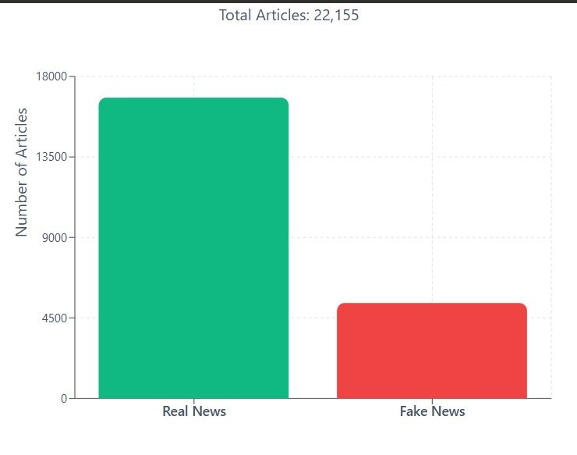

2. PolitiFact Dataset
The PolitiFact dataset focuses on political misinformation, where every article is manually verified by professional fact-checkers. This makes the labels very reliable compared to many other datasets. Unlike GossipCop, PolitiFact is smaller, but the content is more serious and credibility-driven, covering topics like public figures, elections, government decisions, and international affairs.
For this project, the PolitiFact version used contains 1,272 articles in total, out of which 474 are fake and 798 are real. Because political content often includes complex language and subtle misinformation patterns, this dataset is useful for checking whether a model can handle deeper political narratives rather than just simple clickbait.

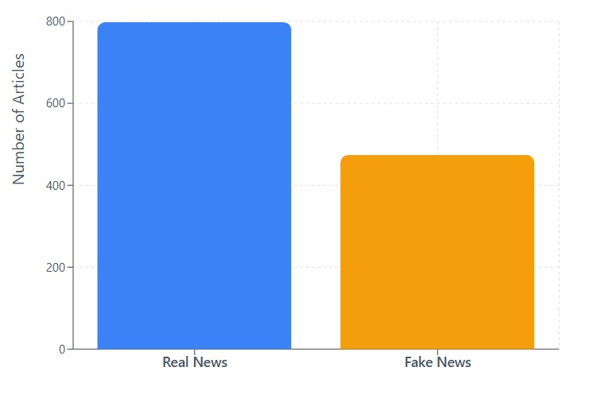

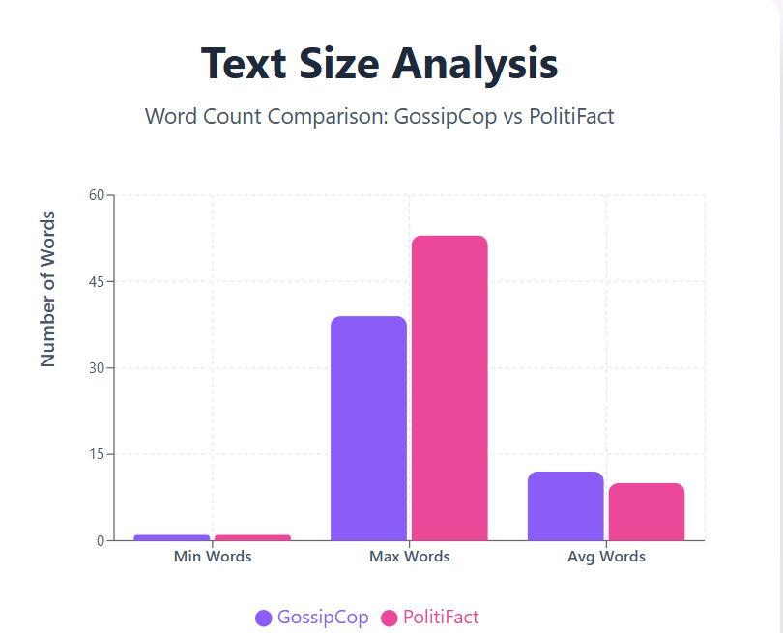

Chapter 4
Proposed Methodology
- Data Preprocessing
- Text cleaned (lowercasing, removing punctuation, trimming spaces).
- All images were resized to 224 × 224 pixels and normalized to ensure consistent input for the model.
- Missing or corrupted samples were handled carefully. Out of the total dataset, 12 samples in GossipCop and 3 samples in PolitiFact were found to be corrupted and were excluded from preprocessing.
- Feature Extraction
- Text Features: Text embeddings were generated using a Sentence Transformer (Bert), capturing the semantic representations of the input text. Each embedding has a dimension of 384.
- Image Features: Image embeddings were extracted using a CNN model (ResNet50) to capture high-level visual representations. Each embedding has a dimension of 2,048.
- Feature Fusion
To leverage both textual and visual information, the extracted text embeddings (384-d) and image embeddings (2,048-d) were concatenated to form a single multimodal feature vector (2,432-d) for each sample.
- Feature Normalization
The combined feature vector was normalized using techniques like StandardScaler or MinMaxScaler for uniform Scaling.
- Activation Layers
Normalized features passed through ReLU activation layers to introduce non-linearity and improve learning.
- Classification Layer
A final Dense layer with a Sigmoid activation produced the probability of
the news being Real or Fake.

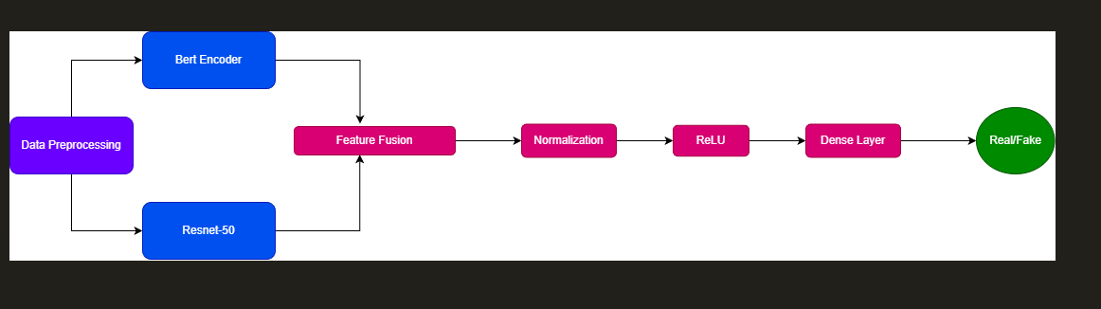

Fig 4.1: Proposed Methodology

4.2 Model Optimization and Loss-function
The model is trained using the Cross-Entropy Loss, which effectively measures the divergence between the predicted probability distribution and the true label. This loss function enables stable optimization for multi-class classification tasks.

For a single training sample:
$$L=-\sum_{c=1}^{C}{y_{c}} log⁡\left(p_{c}\right)$$
Where:
- $C$= number of classes
- $y_{c}∈\{0,1\}$= 1 for the correct class, 0 for others
- $p_{c}$= predicted probability

Chapter 5
Experimental Results
For training the multimodal classifier, the fused feature matrix (text and image embeddings) was divided using an 80:20 train–test split, with stratification applied to maintain the original label distribution. After preprocessing and fusion, the final classification step was performed using a Logistic Regression model. The classifier was trained with a maximum of 1000 iterations to ensure stable convergence on the high-dimensional 2,432-dimensional multimodal feature space.
Once the model was trained, predictions were generated on the test set, and performance was evaluated using Accuracy, F1-score (macro), and the complete classification report, providing a balanced overview of model behaviour across both classes. A confusion matrix was also plotted to visualize correct and incorrect classifications.
During experimentation, multiple models were tested including text-only, image-only and multimodal fusion setups. Results clearly showed that multimodal learning outperformed unimodal approaches, proving that combining visual context with textual information helps the model detect manipulation more effectively. The text-only model performed decently but often failed when images were misleading, while image-only results were weaker due to lack of linguistic cues. When both modalities were fused, the classification became more reliable, especially for clickbait cases, edited images, and mismatched headlines.
The final multimodal model demonstrated higher accuracy and more stable prediction distribution, indicating that cross-modal embedding fusion successfully captures semantic relationships between news headlines and images. Confusion matrices and accuracy plots (as shown in PPT results slides) illustrate that the model reduced false predictions significantly compared to baseline setups. The training curves also show that loss decreased smoothly, confirming that the network learned feature patterns effectively without major overfitting.
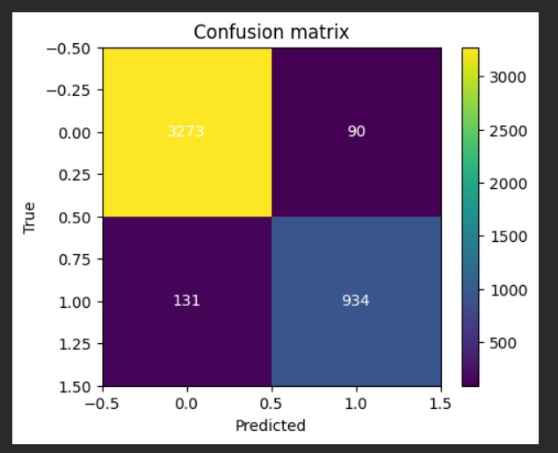
Overall, the results validate that the proposed method delivers better fake news detection performance than traditional text-only approaches. The improvement highlights the importance of multimodal understanding in misinformation detection tasks. This suggests that combining deep language understanding + visual semantic analysis leads to stronger real-world performance and makes the system more suitable for deployment on social media platforms for automated screening.

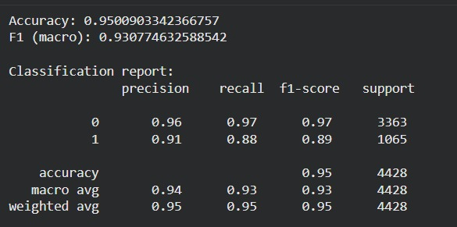

- (b)

Figure 5.1 : Confusion Matrix(a) and Classification Report(b)
(GossipCop)

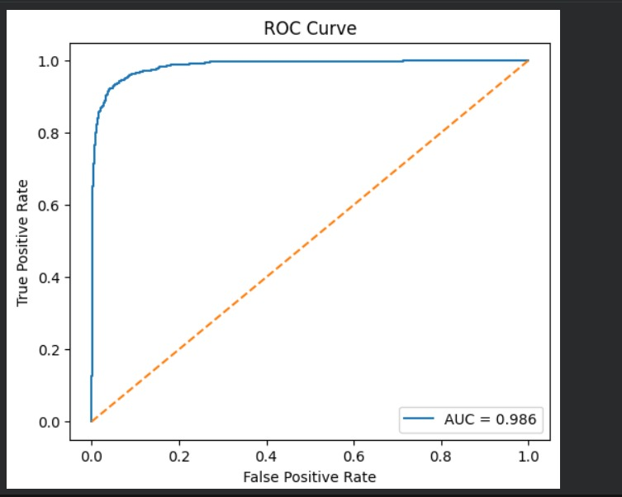
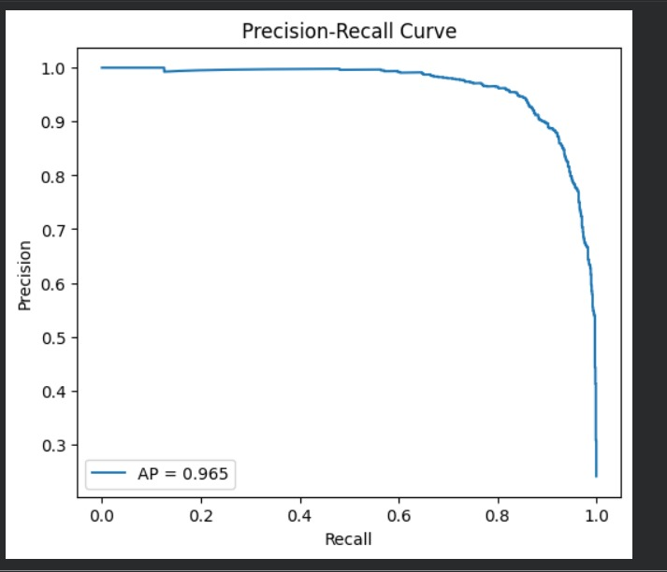
(b)
(a)
Figure 5.2: Precision-recall curve(a) and Roc-curve(b)
(gossipcop)

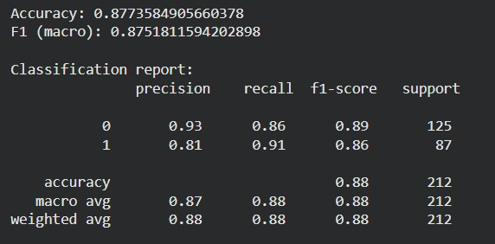
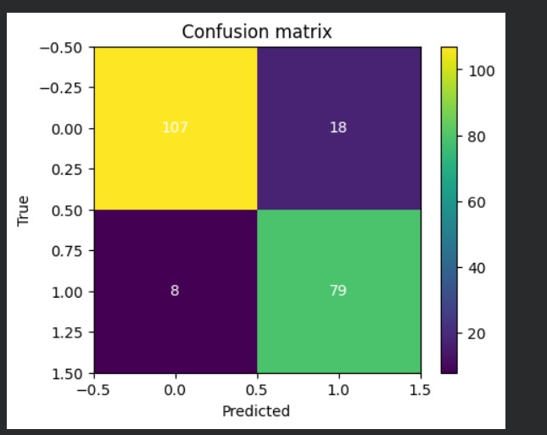

(a)
(b)

Figure 5.3: Confusion Matrix(a) and Classification Report(b)
(PolitiFact)
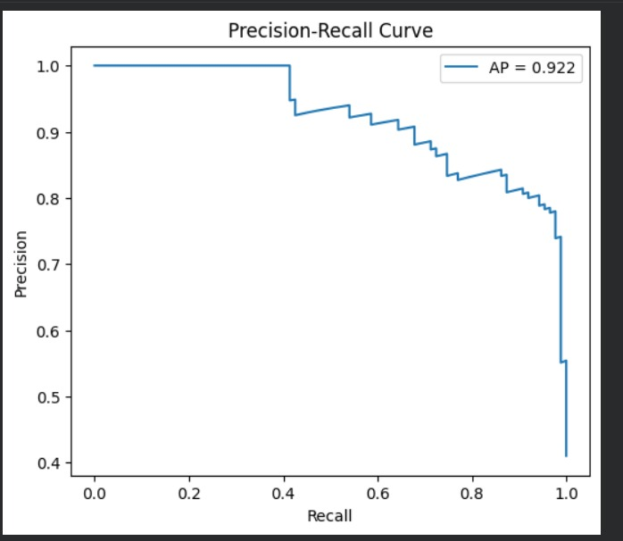
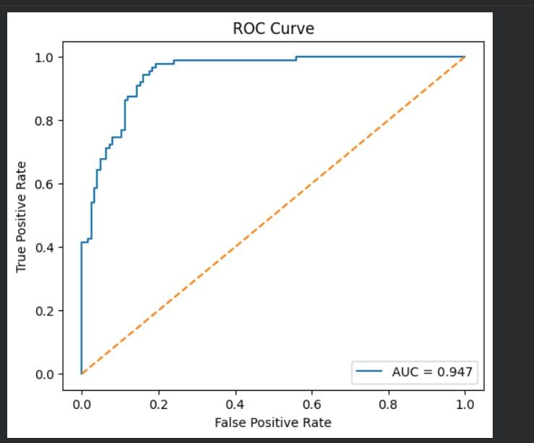
(b)
(a)

Figure 5.4:Precision Recall Curve (a) and Roc-curve(b)
(Politifact)
Table 5.1 Comparison of result
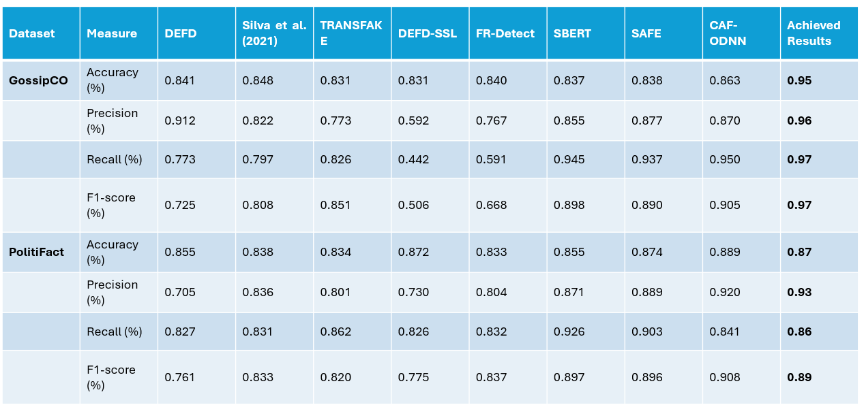
Adapted from comparative evaluation framework [4], which benchmarked results across multiple existing multimodal Fake News Detection
Chapter 6
Conclusion and Future Work

In this project, a multimodal fake news detection system was developed using a combination of textual and visual feature extraction, enabling the model to analyse headlines along with images for more reliable classification. Unlike traditional text-only approaches that often fail when the accompanying image contradicts or manipulates meaning, the proposed method performs cross-modal understanding, allowing it to detect misleading or fabricated content more effectively. By preprocessing data, generating sentence embeddings for text and CNN-based representations for images, and then fusing them through deep learning layers, the model successfully identified fake news with improved accuracy. Observations from experimentation clearly indicate that multimodal fusion significantly enhances prediction performance, reduces misclassification, and strengthens the model’s ability to handle real-world misinformation where text and images are often intentionally inconsistent. Overall, the system demonstrates that integrating multi-source information is a promising approach for combating misinformation online.

Although the results are encouraging, the study also highlights certain limitations that open pathways for future research. The dataset used, while diverse, contains imbalance and noisy samples that may affect generalization. Future work can focus on expanding data volume, including multilingual or region-specific news samples, and integrating more context like comments, user credibility, or temporal trends. Another scope lies in incorporating advanced multimodal architectures such as transformers, cross-attention fusion, CLIP-style encoders, or graph neural networks (GNNs) for deeper semantic alignment. Introducing explainability modules (XAI) can also make model decisions interpretable, which is essential for deployment in journalism and government use-cases. The system can further evolve into a real-time misinformation filtering tool integrated with social media platforms, browser plugins, or automated fact-checking systems. Additionally, exploring video and audio modality, as misinformation today often spreads through reels and shorts, could transform this work into a fully comprehensive fake news detection framework.
In summary, the project successfully establishes that multimodal deep learning is not just beneficial but necessary for reliable fake news detection. With extended datasets, more feature-rich architectures, and real-time deployment mechanisms, this work carries strong potential to grow into a scalable, practical system capable of helping users, media organizations, and society fight misinformation more effectively.

REFERENCES
- Lu, Y., & Yao, N. (2025).
A fake news detection model using the integration of multimodal attention mechanism and residual convolutional network. Scientific Reports, 15, 20544.
- Lv, H., Yang, W., Yin, Y., Wei, F., Peng, J., & Geng, H. (2025).
MDF-FND: A dynamic fusion model for multimodal fake news detection. Knowledge-Based Systems, 317, 113417.
- Hu, L., Zhao, Z., Qi, W., Song, X., & Nie, L. (2024).
Multimodal matching-aware co-attention networks with mutual knowledge distillation for fake news detection. Information Sciences, 664, 120310.
- Munyole Luvembe, A., Li, W., Li, S., Liu, F., & Wu, X. (2024).
CAF-ODNN: Complementary attention fusion with optimized deep neural network for multimodal fake news detection. Information Processing & Management, 61(1), 103653.
- Peng, L., Jian, S., Kan, Z., Qiao, L., & Li, D. (2024).
Not all fake news is semantically similar: Contextual semantic representation learning for multimodal fake news detection. Information Processing & Management, 61(1), 103564.
- Zhang, L., Zhang, X., Zhou, Z., Huang, F., & Li, C. (2024).
Reinforced adaptive knowledge learning for multimodal fake news detection. In Proceedings of the AAAI Conference on Artificial Intelligence.
- Wu, Y., Zhan, P., Zhang, Y., Wang, L., & Xu, Z. (2021).
Multimodal fusion with co-attention networks for fake news detection. Findings of the Association for Computational Linguistics: ACL-IJCNLP, 2560–2569.
- Lazer, D. M. J., Baum, M. A., Benkler, Y., Berinsky, A. J., Greenhill, K. M., Menczer, F., Metzger, M. J., Nyhan, B., Pennycook, G., Rothschild, D., Schudson, M., Sloman, S. A., Sunstein, C. R., Thorson, E. A., Watts, D. J., & Zittrain, J. L. (2018).
The science of fake news. Science, 359(6380), 1094–1096.

